Control Systems Lab

Solving ODEs with Simulink:

Objectives
- Learn how to solve ODEs with m-files and Simulink
- Learn how ODEs are numerically solved, and what this different terminology is
This is a simulation only lab – no hardware is needed.

Introduction
In class you were introduced to numerical methods such as Euler’s method that can approximate the solution of an ordinary differential equation (ODE). In this tutorial you will learn how to solve an ODE using Simulink, which uses a numerical solver that works similar to Euler’s method. First, you will construct a diagram in Simulink that represent the ODE. Then you will write a script (m-file) in MATLAB that defines certain parameters, runs the simulation, and plots the results.
Note that Simulink is not the only way to solve an ODE – it is possible to write code solely in MATLAB to set up the ODE, define parameters, and run the solver. However, the Simulink approach can handle generic relationships such as nonlinearities and feedback control architecture, and has the benefit of representing the system visually.
Table of Contents
Objectives 1
Introduction 1
Solving ODEs with Simulink 3
Writing the ODE in Simulink 3
Specify Solver Settings 5
Define Parameters in a m-file and run simulation 6
Define outputs, run simulation and plot the results 8
Saving data 11
Specifying the output interval – get more data 11
Basic Plotting commands 13

Solving ODEs with Simulink
Consider the ODE for a simple inverted pendulum with specified initial conditions. The input is a torque $T$, and known parameters $m, g, L, I$.
$$I\ddot{θ}=mgL\sin{θ}+T$$
The general steps are:
- Write these equations in Simulink
- Specify solver settings
- Define parameters, simulate (solve) the equations
- Plot the results

Writing the ODE in Simulink
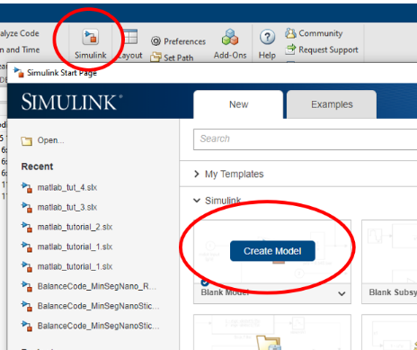
This equation will be constructed from various Simulink blocks. First is to solve the equation for the highest derivative, in this case $\ddot{θ}$, then write this equation in Simulink.
$$\ddot{θ}=\frac{1}{I}(T+mgl\sin{θ})$$
Open Simulink and create a blank new model. Save the model as “Pendulum_model”. The easiest way to add blocks is to click in the main window and just start typing the name of the block you want, for example start typing “integrator” and then select the desired choice. Alternatively search through the available blocks with the Library Bowser.
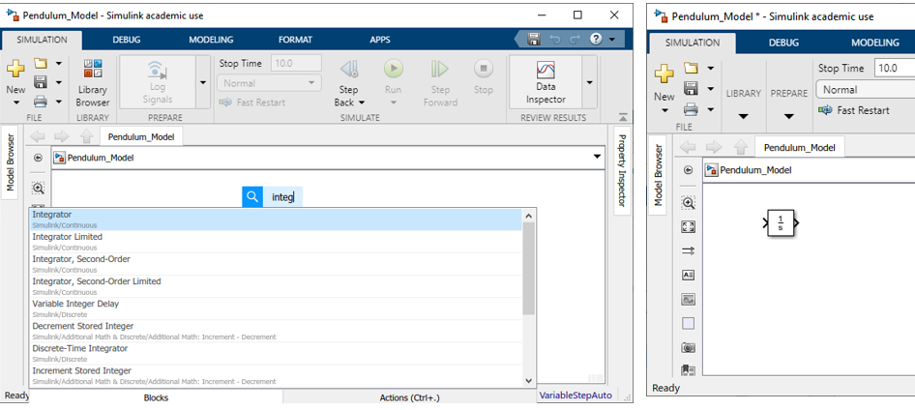
Blocks can be copied, or you can control-click and drag to create a copy. Add two integrators and connect them. Label each signal by typing the text and then pressing enter:
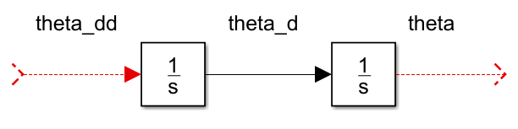
These are now the signals that are available. $\ddot{θ}$ was integrated to obtain $\dot{θ}$ and integrated again to obtain $θ$. Now the equation for $\ddot{θ}$ can be written from the available signals:
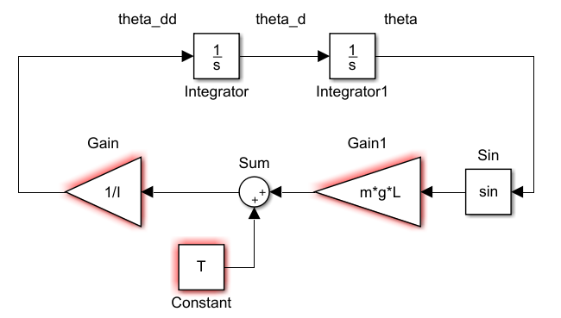
- Show block names by selecting the blocks, right-clicking, and selecting “format”
- Red outlines indicate values for I, m, g, L, and T have not been defined. Simulink numerically integrates the equations so if it does not have numbers for these values it cannot solve the equation. These will be defined later.
- Rotate blocks by selecting the bock and clicking control+r.
- Assign initial conditions by double-clicking each integrator. The first integrator on the left is the initial condition for velocity $\dot{θ}\left(0\right)$ the second integrator on the right is the initial condition for position $θ\left(0\right)$. The red indicates there is no value assigned yet.
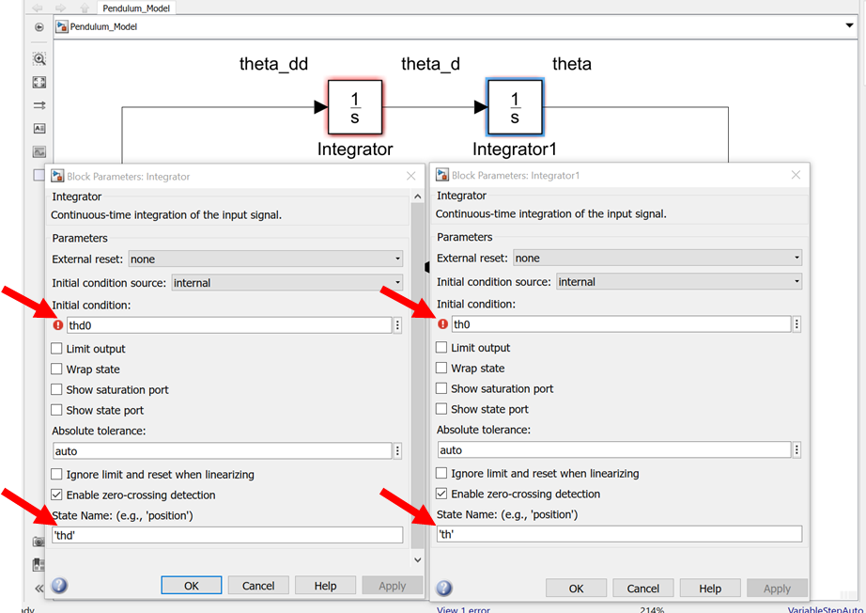
The ODE is now written in Simulink and the initial conditions have been specified. Notice that the equation can easily be “read” form the Simulink diagram:
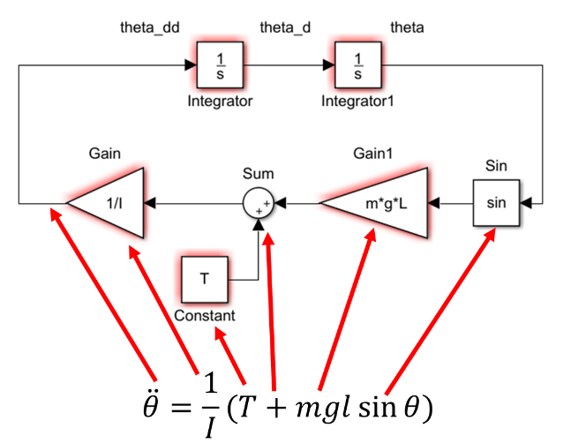

Specify Solver Settings
Access the solver settings by selecting the “Modelling” tab, clicking the gear icon for “Model Settings”. Or by right-clicking in the main diagram and selecting “Model Configuration Parameters” form there. The stop time and solver type are also indicated on the diagram.
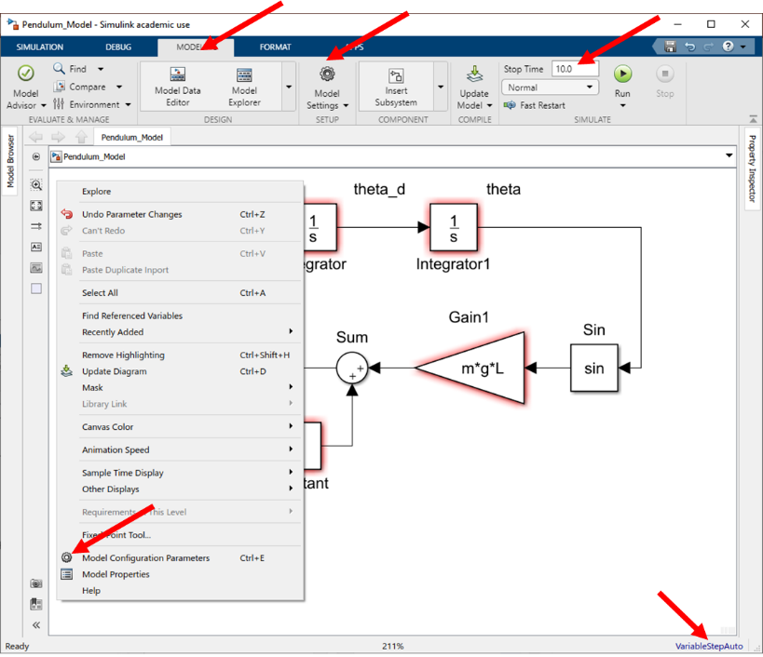
Set the stop time to “tstop” and leave the other settings. The software will decide the time step size and solver to solve the ODE. These settings will be discussed later.
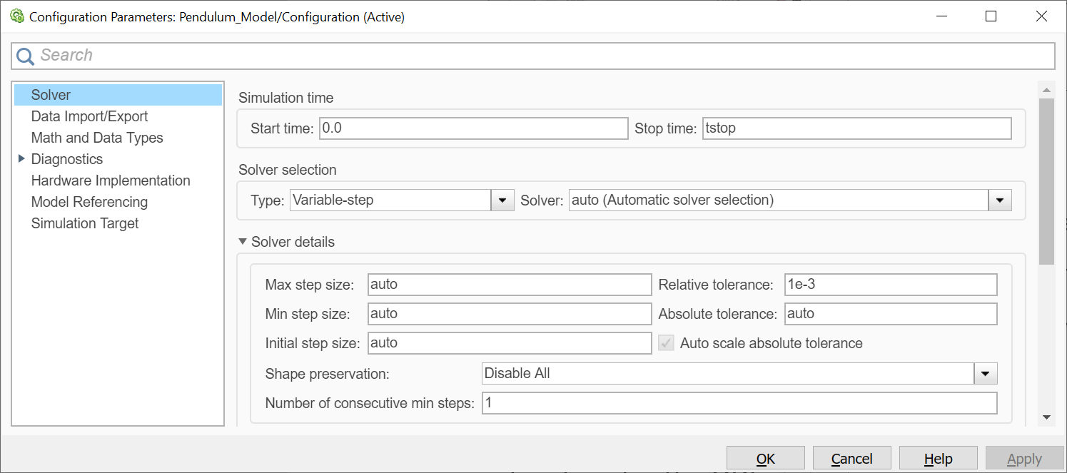
Select “Data Import/Export”:
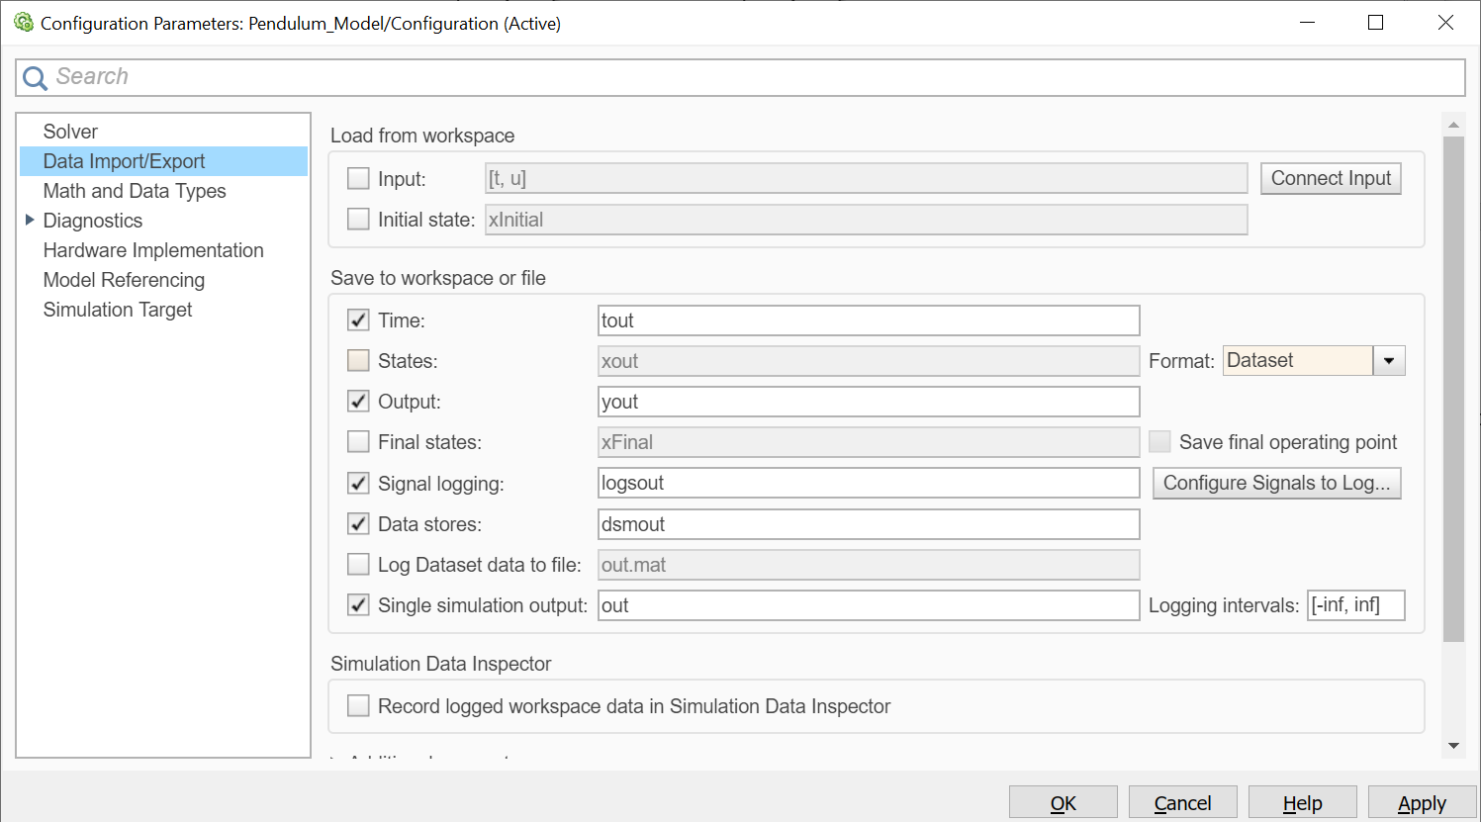
This shows what data Simulink will store. This will be modified later.

Define Parameters in a m-file and run simulation
All the parameters ($m, g, L, I$), initial conditions (th0, thd0), inputs (T), and solver variables (tstop) need to be defined before the ODE can be solved. Matlab is a numerical tool and all variables must have number values. These values can be defined from the command line, but it is more efficient to define these in a m-file (script). From the Editor tab in MATLAB create a new script, save this file as “Pendulum_Simulation” and in this file enter all the parameters for the model and simulation.
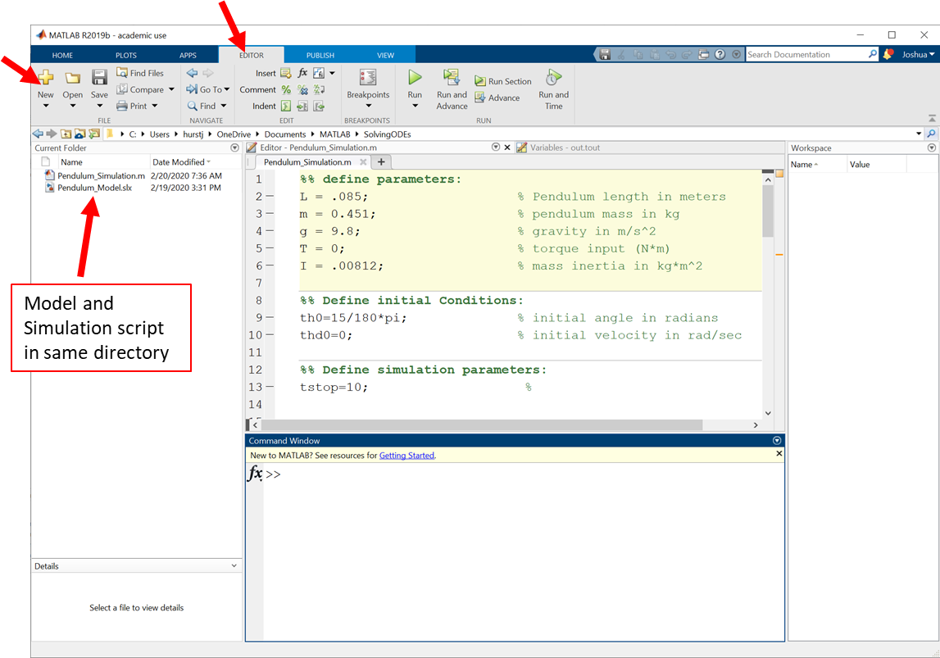

Run the script and by pressing the green play button or with the keyboard shortcut F5 all the values will be defined for the simulation:
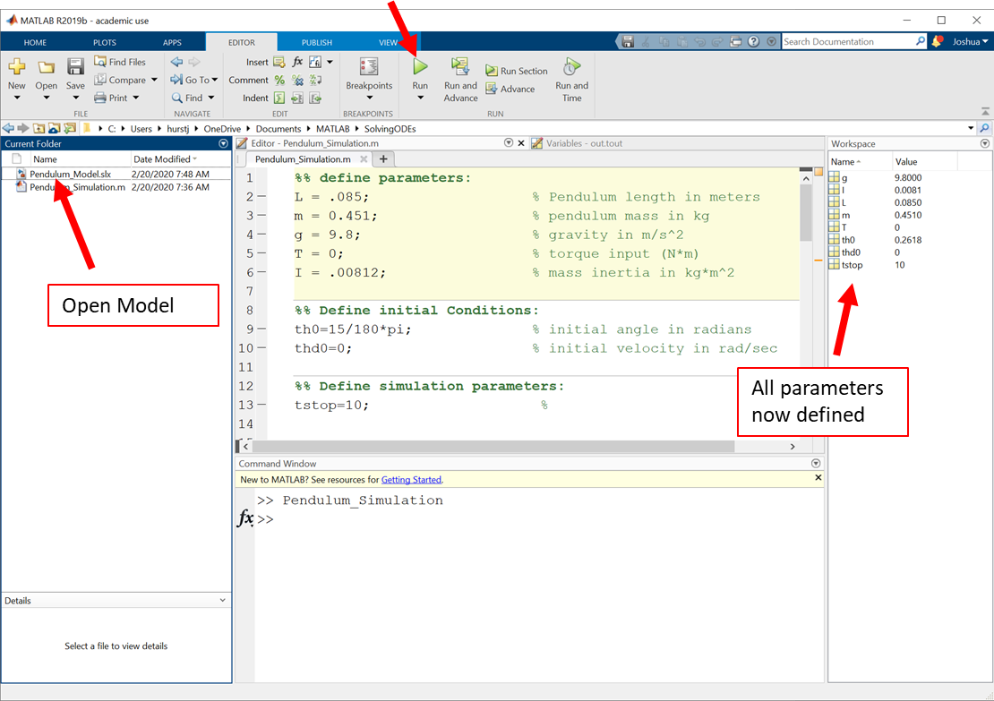

Open the model and now all the red highlighting is removed indicating all the parameters have been defined. Now the ODE can be solved by pressing the green Run button.
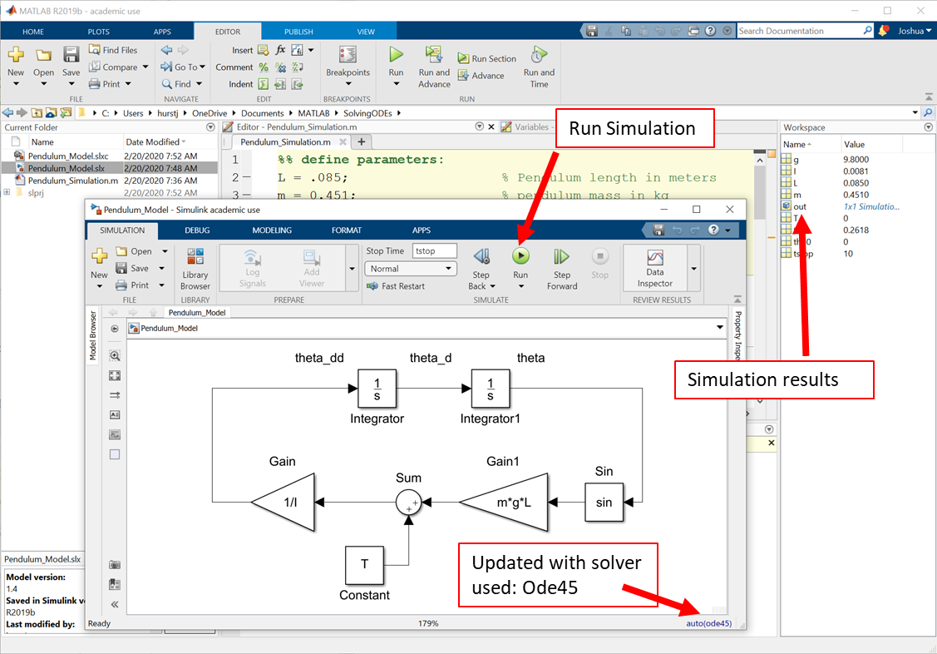
If an error message appears read all the information posted about the error. Usually it will provide you enough information to understand what the specific problem is. If it solves the ODE successfully it will store some information in the “out” variable and you can access this information by double clicking this variable. By default the usual outputs of interest $θ$ and $\dot{θ}$ are not logged.

Define outputs, run simulation and plot the results
The simplest way to get access to the signals is to use “to workspace” blocks and store each signal in an array. Add a clock for time, and “to workspace” blocks for each of the integrator outputs (states) to log $t, θ, \dot{θ}$.

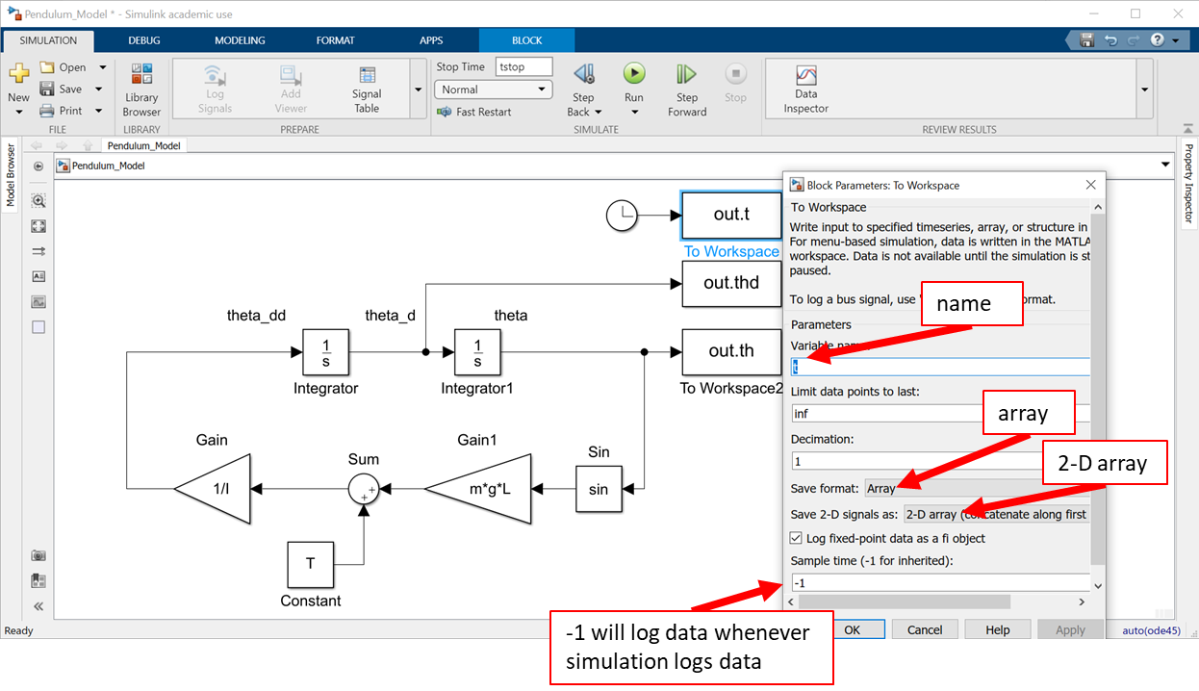
In the main simulation diagram press “Control+E” to open the model configuration parameters (or right-click and select “model configuration parameters”). Got to Data Import/Export and unselect all of the “Save to workspace commands” and click apply.
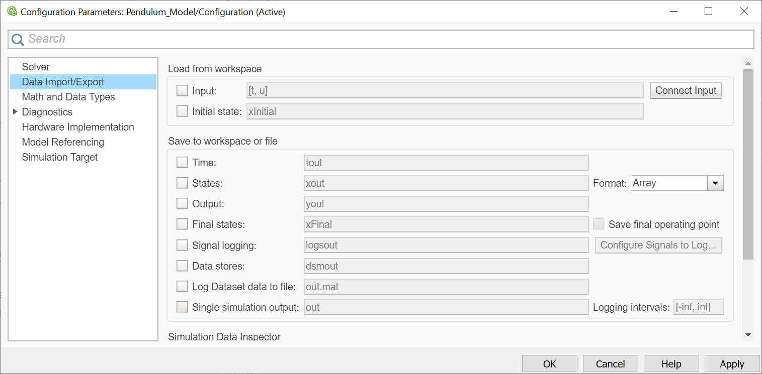
Now the data will be written directly to array variables specified in the to workspace blocks instead of the single simulation output “out”:
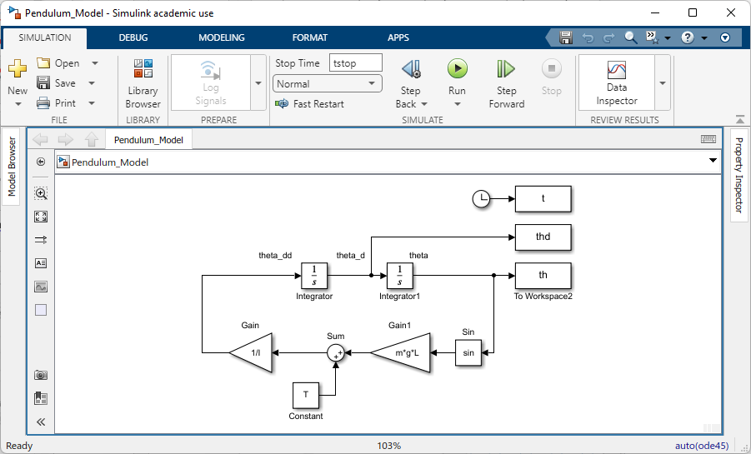
Edit the script file to first run the simulation diagram using the ‘sim’ command, and then plot the results:
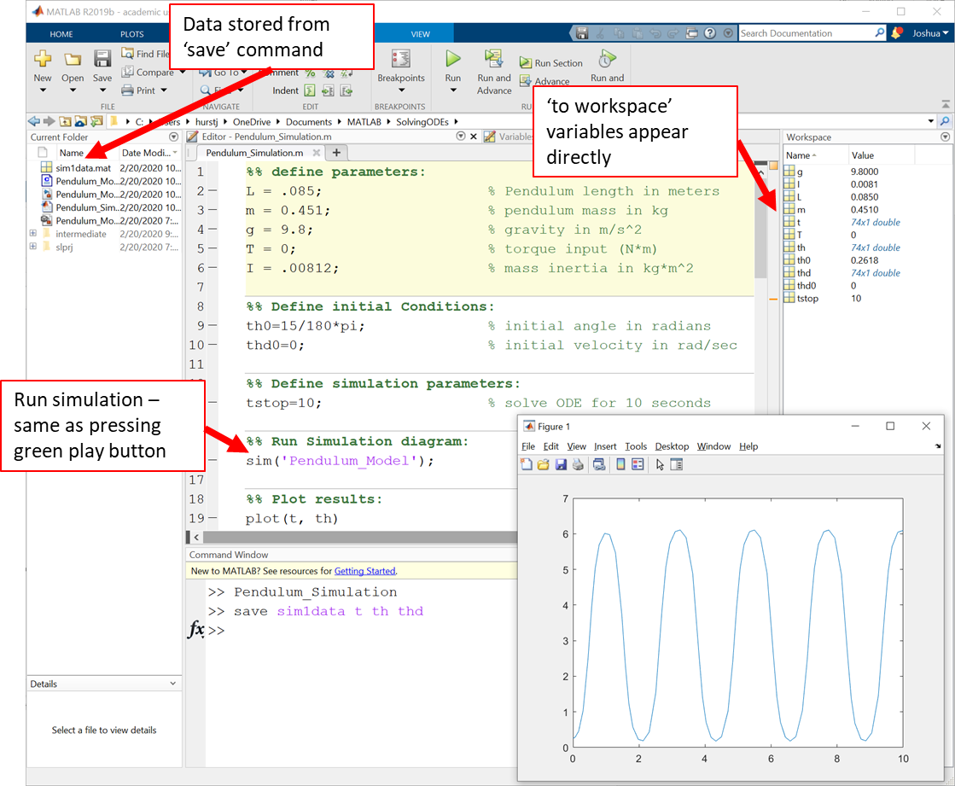
Notice the “to workspace” variable appear directly in the workspace now and can then be easily plotted.

Saving data
The easiest way to save data is to select variables you want to save by shift-clicking the variable names in the Workspace then right-click, save-as as shown below for a different lab. You do not have to do this for this tutorial, but will use this in future labs.
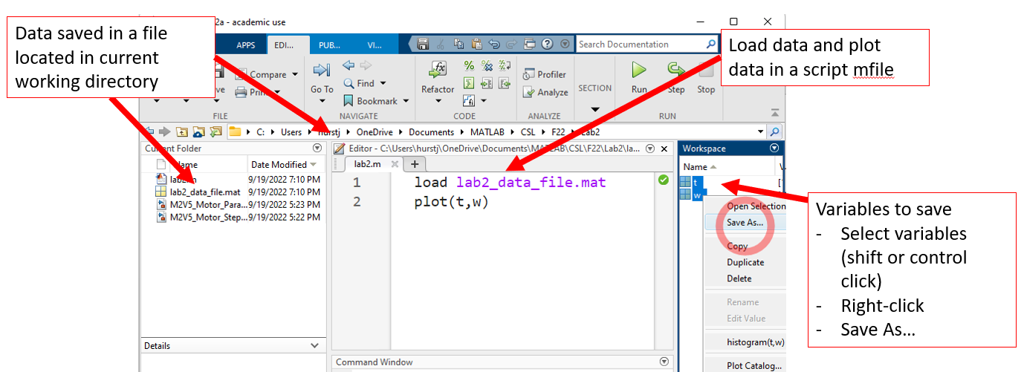

Specifying the output interval – get more data
The plotted response is not as “smooth” as you might expect. The data points are accurate, but there may not be enough data points to plot a smooth curve. In the command line type “t” so see the vector for the time variable “t” or double-click the variable in the Workspace.
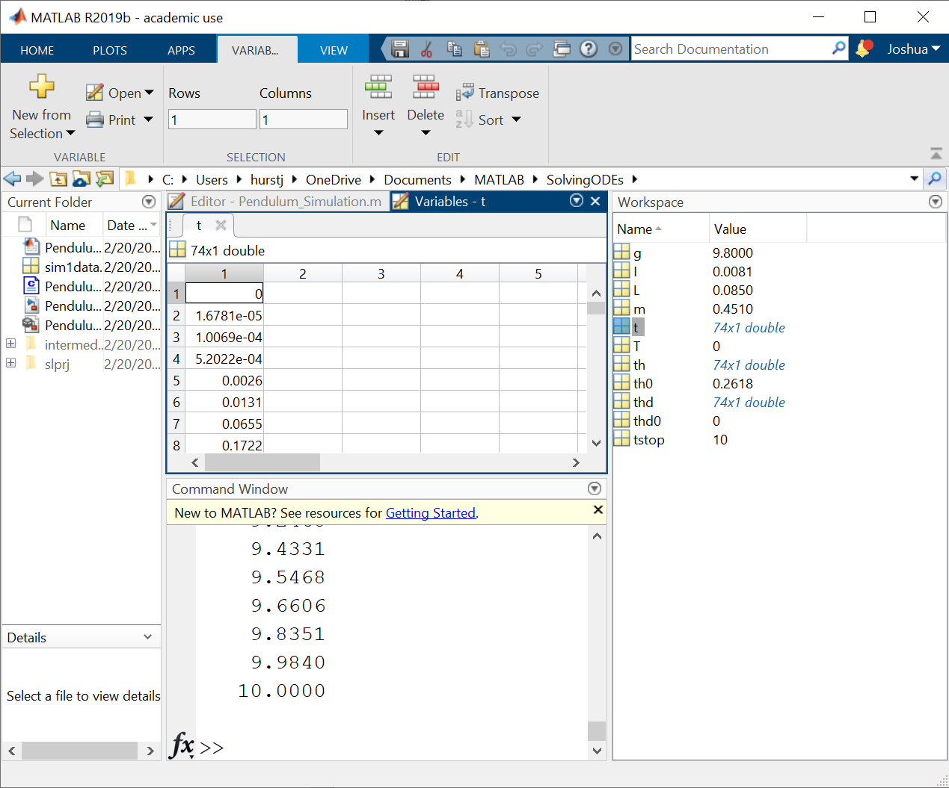 Notice that the returned points for “t” are not evenly spaced. The Solver returns data whenever it is convenient when it is calculating the solution. In the “to workspace” blocks the sample time was set to “-1” which means data will get logged whenever the solver decides to log data.
To obtain data at a specified interval define that interval in the script and update the sample time in the “to workspace” block with this value:
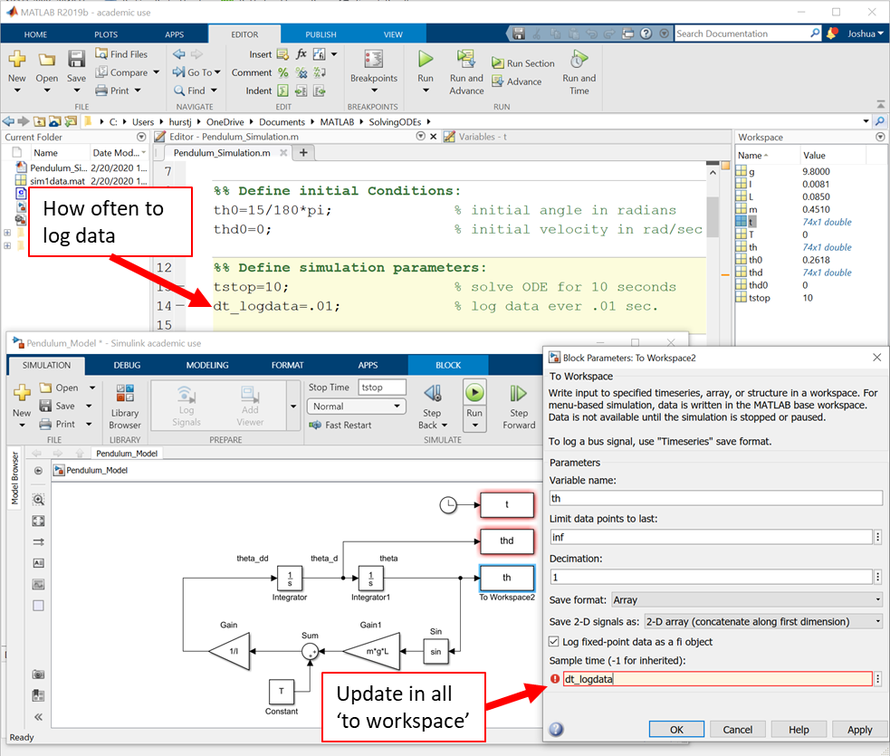
Now run the script and notice the smooth response:
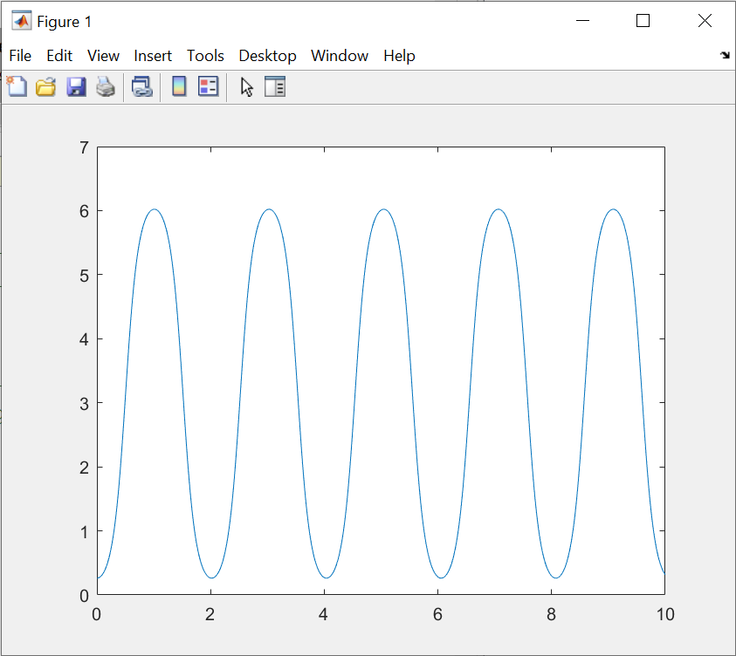
The data is now logged every 0.01 seconds resulting in a smooth curve.

Basic Plotting commands
Modify the script to add legend, and labels to the response:
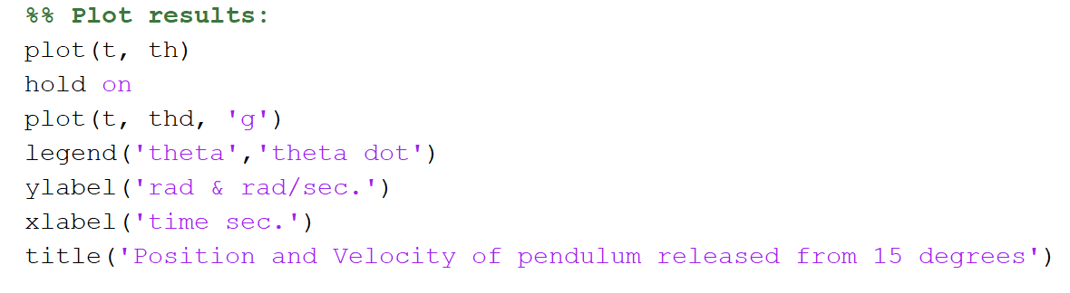
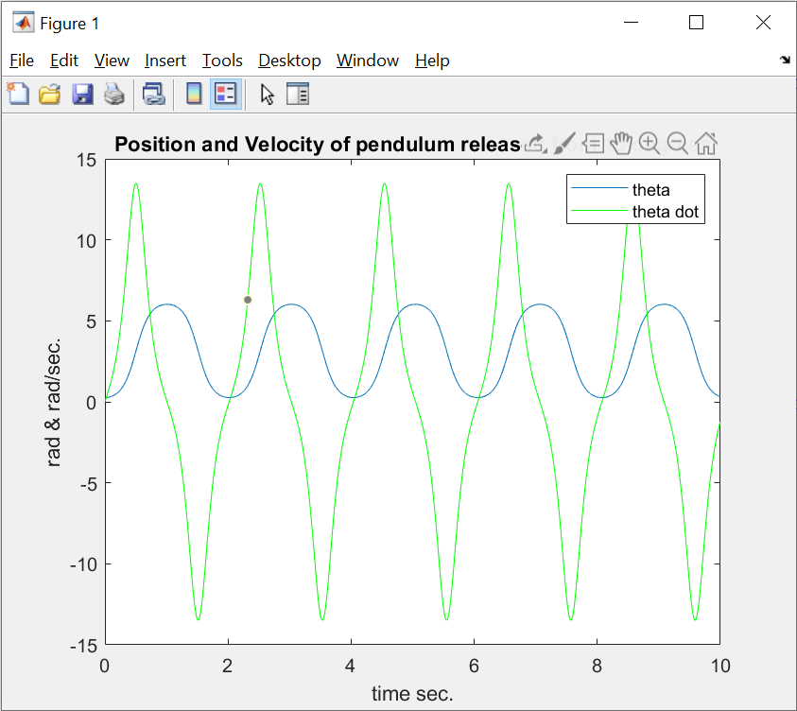
If you want to learn more about a command type use the “help” function at the command line, for example “help plot”
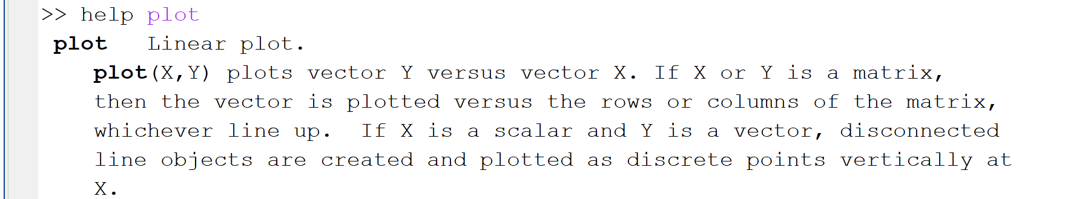

Arrange your Matlab, Simulink and Figure windows and take a screenshot for uploading to your lab submission later:
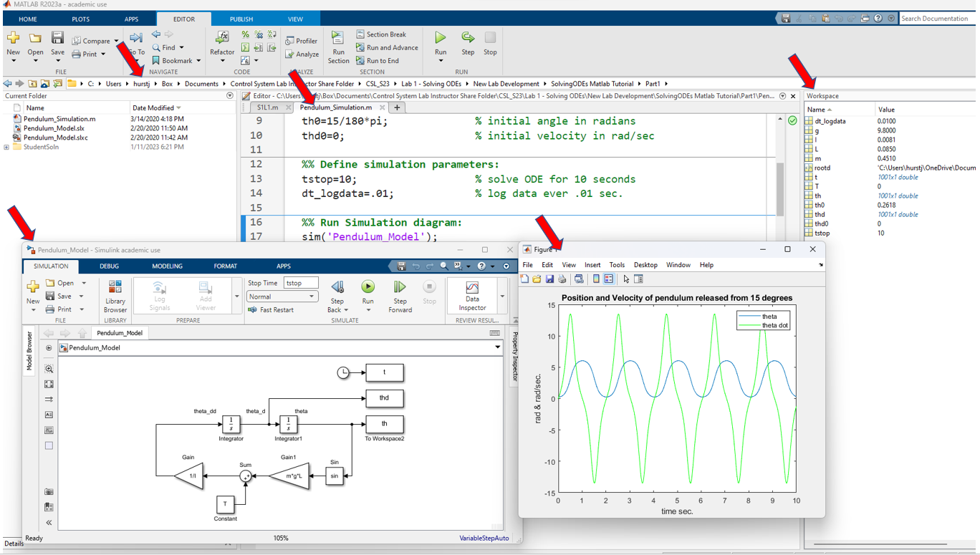
Make sure your screenshot shows:
- The path to your file with your username
- Your script code
- Your Simulink diagram
- Your final figure – don’t forget to put your NAME in the title!
- The workspace variables

